
Life cycle analysis shows:
Refrigerated cardboard boxes are not better for the environment than EPS fish boxes.

Commissioned by: | Stybenex (Netherlands)
Published on: | 16 May 2024
Note: | This content was shared by Rogier Ries, President of Sybenex – the National Association of EPS in the Netherlands, to Ingrid Morin, Communications Managers of EUMEPS, on Thursday 16th of May 2024.  The original content was published here: https://slimverpakken.nl/verpakkingen/levenscyclusanalyse-toont-aankoeldoos-van-karton-is-niet-beter-voor-milieu-dan-een-eps-doos/

In a comparative life cycle analysis, the environmental effects of cardboard coolers were compared with those of coolers made from expanded polystyrene (EPS). Contrary to public opinion, cardboard coolers do not appear to be more environmentally friendly than their EPS counterparts. The study indicates that the CO₂ impact of both types of boxes is likely equivalent, while EPS boxes score better on the overall environmental footprint and significant specific environmental effects, such as emissions to water.

Cardboard versus EPS
The study compared the 'Papercooler', a fully cardboard cooler, and the 'EcoCooler', a larger variant with cardboard walls filled with cellulose insulation material, with their respective EPS equivalents of the same size.

Environmental Footprint
According to the Product Environmental Footprint (PEF), a metric that quantifies the environmental impact of products throughout their entire life cycle, the impact measured in the study for the cardboard Papercooler and Ecocooler is as much as 2.91 and 1.55 times greater than that of EPS coolers. This difference becomes even clearer when we look at specific environmental effects.

Specific Environmental Effects
The impact on freshwater organisms from toxic substances released into the environment is 201 times greater for the cardboard Papercooler and 96 times greater for the cardboard Ecocooler compared to EPS. Additionally, the environmental impact due to potential global warming from changes in land use is 75 and 38 times greater for the Papercooler and Ecocooler, respectively, than for the comparable EPS cooler.
info@eumeps.org 71 Av. de Cortenbergh IBAN: BE54 2100 6969 9097 Transparency Register No.:
eumeps.org 1000 Brussels, Belgium VAT: BE 045 312 7976 02100645398-66
• Want to see all the results at a glance? Download our factsheet with the key results of this comparative life cycle analysis.

Debunking General Perception
These results debunk the general perception that cardboard is a more environmentally friendly packaging material. The results also align with the increasing number of studies and reports showing that replacing plastic packaging with paper is not necessarily a sustainable solution. Furthermore, the findings of the life cycle analysis demonstrate that the choice of packaging materials requires attention to the total environmental impact throughout the entire production process.

Do you have questions about this comparative LCA study? Email your question to r.goes@stybenex.nl.

Content of the factsheet
Comparison of Environmental Impact of Cooler Boxes
Cardboard refrigerated boxes do not score environmentally better than EPS refrigerated boxes. The CO2 impact of EPS and cardboard boxes is probably equivalent. On other impacts, EPS refrigerated boxes probably score better, especially on impacts related to emissions to water.

Small Cooling box | EPS | Cardboard | Conclusion
Integrated assessment of the environmental impacts of EPS and cardboard throughout the entire life cycle. |  | 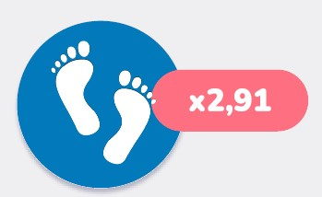 | The environmental footprint of the cardboard cooler box is 2.91 times larger than that of the EPS refrigerated box.
Climate change - Total |  | 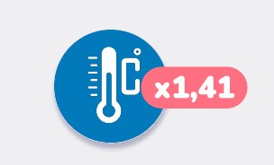 | The cardboard refrigerated box contributes 1.41 times more to the potential global warming through airborne greenhouse gas emissions.
Climate change - Fossil resources | 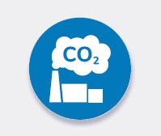 | 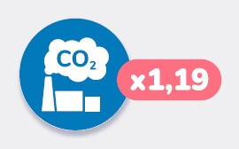 | The potential global warming from airborne fossil  greenhouse gas emissions is 1.19 times greater for a cardboard box.
Climate change -Biobased resources | 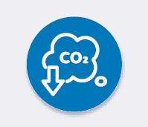 | 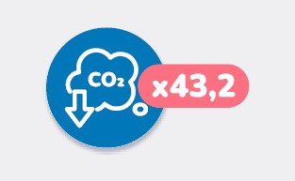 | Compared to EPS, a cardboard cooler box has a 43.2 times greater impact on the potential global warming due to the emissions of biobased greenhouse gases in the air.
Page | 2

Climate change - Land-use changes |  |  | The environmental impact due to potential warming of the earth though land use changes  is for the cardboard refrigerated box 75 times greater than for the comparable EPS cooling box.
Ecotoxicity: freshwater to water |  | 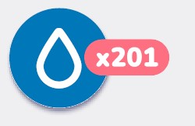 | The impact on freshwater organisms of toxic substances released into the environment is 201 times greater for the cardboard cooler 201 times greater than for EPS.
Depletion of abiotic raw materials – fossil fuels |  | 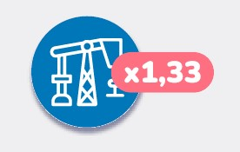 | The EPS cooling box contributes 1.33 times less to the depletion of natural fossil fuels.
Source: Indicative LCA packaging boxes - SGS Intron BV - Research results of Cool Box Small - Dutch recycling figures 223
Page | 3

